**ITS 26000 – Applied Database Tech**

**Lab 04 – (100 points)**

**Questions:**

**KimTay Pet Supplies: Module3: Q1, Q2**

**StayWell Student Accommodation: Module3: Q1, Q2**

**KimTay Pet Supplies:**

1. Create a table named REP. The table has the same structure as the SALES_REP table shown in Figure 3-15 except the LAST_NAME column should use the VARCHAR data type and the COMMISSION and RATE columns should use the NUMERIC data type. Execute the command to describe the layout and characteristics of the REP table. (25 points)

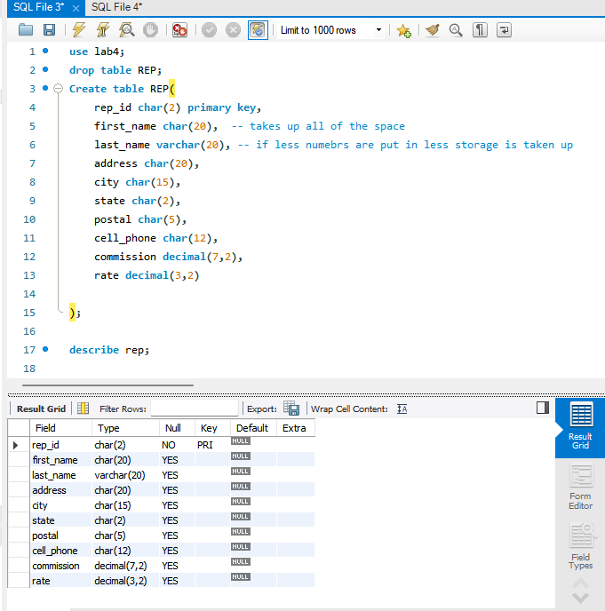

1. Add the following row to the REP table: rep ID: 35, first name: Fred; last name: Kiser; address: 427 Billings Dr.; city: Cody; state: WY; postal: 82414; cell phone: 307-555-6309; commission: 0.00; and rate: 0.05. Display the contents of the REP table. (25 points)

**Can you add all those values into this new row? If not, explain before you write your SQL statement.**

**Yes I can add all those values into this new row.**



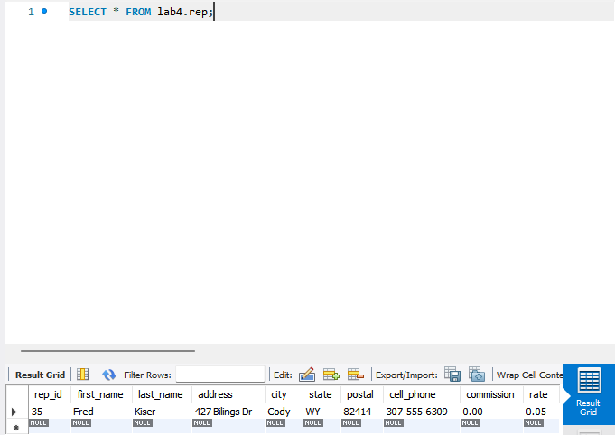

**StayWell Student Accommodation:**

1. Create a table named SUMMER_SCHOOL_RENTALS. The table has the same structure as the PROPERTY table shown in Figure 3-48 except the PROPERTY_ID and OFFICE_NUMBER columns should use the NUMBER data type and the MONTHLY_RENT column should be changed to WEEKLY_RENT. Execute the command to describe the layout and characteristics of the SUMMER_SCHOOL_RENTALS table. (25 points)

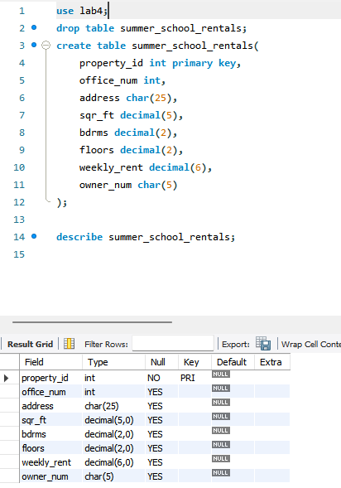

1. Add the following row to the SUMMER_SCHOOL_RENTALS table: property ID: 13; office ID: 1; address: 5867 Goodwin Ave; square feet: 1,650; bedrooms: 2; floors 1; weekly rent: 400; owner number: CO103. (25 points)

**Can you add all those values into this new row? If not, explain before you write your SQL statement.**

**Yes I can all those values into the new row.**

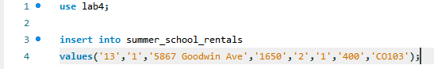

**Deliverables:** Document Report with question and answer (either word or pdf file) need to be uploaded into Brightspace in one submission